**INDEXES**

**INDEXES** ARE DATABASE OBJECTS TO "**PRESORT**" THE TABLE DATA FOR FASTER SEARCH

OPERATIONS. DEFAULT SORT AREA IS "**MEMORY**". WE CAN ALSO USE "**TEMPDB**" TO SORT DATA.

**INDEX ARCHITECTURE**:

DATABASE CONTAINS FILEGROUPS. EACH FILEGROUP CONTAINS FILES. EACH FILE IS DIVIDED INTO "PAGES". SIZE OF EACH PAGE = 8 KB.

**TYPES OF PAGES**

**1.** INDEX PAGE : USED TO STORE THE INDEX INFORMATION

**2.** DATA PAGE : USED TO STORE THE TABLE DATA

WHENEVER WE CREATE INDEX, IT RESULTS IN THE CREATION OF "**INDEX PAGES**".

THESE INDEX PAGES CONTAIN LINK / ADDRESS TO THE ACTUAL DATA PAGES.

THESE INDEX PAGES ARE ORGANIZED INTO A STRUCTURE CALLED "**B TREE**" INSIDE THE DATABASE DATA FILE. **BINARY TREE**

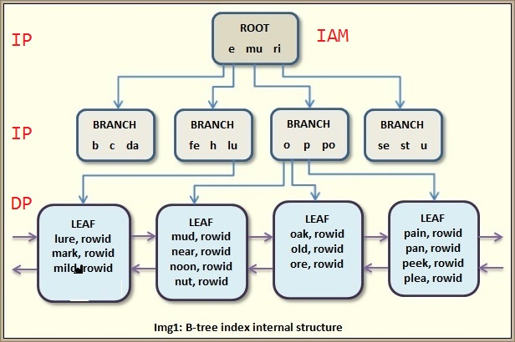

EVERY "B TREE" CONTAINS FOLLOWING ENTITIES:

**ROOT PAGE**: REFER TO START LOCATION OF INDEX. IAM[**INDEX ALLOCATION MAP**] PAGE

**BRANCHES**: REFER TO INDEX PAGES FOR FASTER DATA PAGE ACCESS

**LEAF PAGES**: REFER TO THE ACTUAL DATA PAGES THAT STORE TABLE DATA

**TYPES OF INDEXES**:

**CLUSTERED INDEX** : USED TO **CONTROL DATA PAGES**. COMBINE INDEX & DATA TOGETHER

**Clustered Index will take the query to the actual table data. Up to 1**

**NON CLUSTERED INDEXES**: USED TO REFER TO DATA PAGES. DATA NOT COMBINED WITH INDEX

**INCLUDED INDEXES** : THESE INDEXES INCLUDE ADDITIONAL COLUMNS FOR FASTER SEARCH

**COLUMNSTORE INDEXES** :THESE INDEXES ARE USED TO STORE ONLY UNIQUE VALUES OF COLUMN

**Used for DISTINCT, GROUP BY, etc..**

**FILTERED INDEXES** : INDEXES DEFINED ON FEW ROWS OF THE TABLE BASED ON CONDITIONS.

EX: TO INDEX ACTIVE PRODUCTS

**ONLINE INDEXES** : THESE INDEXES ARE AVAILABLE FOR USE DURING THEIR CREATION ITSELF.

BY DEFAULT, INDEXES ARE AVAILABLE FOR USE ONLY AFTER THEIR COMPLETE CREATION. BUT **ONLINE INDEXES** ARE READILY USED BY QUERIES **DURING** THEIR CREATION ITSELF.

**COVERING INDEX** : SUCH INDEX THAT INCLUDES ALL COLUMNS USED IN THE QUERY.

IF A SELECT QUERY CONTAINS 8 COLUMNS.

ANY INDEX THAT INCLUDES ALL 8 COLUMNS IS CALLED A COVERING INDEX

FOR THAT QUERY.

**INDEXED VIEWS** = **MATERIALIAZED VIEWS**.

USED TO STORE THE QUERY AND THE QUERY RESULT (DATA).

USED IN SCENARIOS WHERE WE NEED TO PERFORM REPEATED READS.

MEANING READING THE SAME DATA MULTIPLE TIMES WITHIN A REPORT.

FOR THIS PURPOSE, WE CREATE A **UNIQUE CLUSTERED INDEX** ON VIEWS.

EX: A LIVE CRICKET MATCH